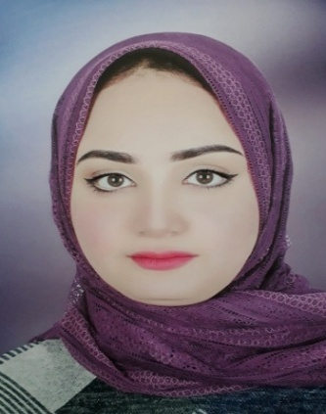

**Personal information**

**Address**

78-Al Mahta St ,Sohag Awal, Sohag

**Phone**

01143415371,

01552486269

**E-mail**

[emanaboelsoud21@gmail.com](mailto:emanaboelsoud21@gmail.com)

**Date of Birth**

21 July 1996

**EMAN ABO EL SOUD KHALF**

Objective

Seeking challenging position in reputable Company which will be Suitable to improve my skills and enhance my experience, l am Ambitious ,eager to learn and l have the ability to deal wih all Categories of Clients

Education

________________________________________________________________________

* Bachelor of commerce English Section _Sohag University
* Major :Accounting - Graduation Year: (2018)
* Grade:Good (78,65%)

Courses

* English cources (general,conversation ,business )
* ICDL courses

Skills

________________________________________________________________________

Personal Skills

* Ability to Face&Solve problems
* Commitment and accepting responsibility
* Ability to work under pressure _Team work
* Ability to meet deadlines successfully and maintaining quality of work

Computer Skills

* Very Good In Using (Word,Excel ,PowerPoint,outlook)
* Very good in surfing skills on internet

**Language Skills**   
Arabic:_Mother Tongue

English:_ very Good in (Writing ,Speaking ,listening )