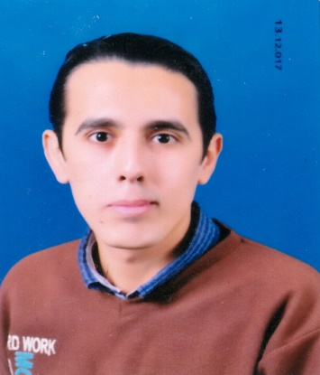
Curriculum Vitae

Name: Ishak Sami Shohody
Mobile: 01225306686
Address: Idfa , Sohag, Egypt
Email: ishak.sami2013@yahoo.com

Objectives

Obtain a challenging position and to be involved with people I could learn from and improve my skills to be effective, qualified and worthy in my field.

Education

- Faculty: High Institute Of Engineering and technology El Tood - Luxor
- Department: Civil Engineering Department
- Degree: Bachelor in Civil Engineering ( 71% )
- Graduation Date : June, 2018
- Graduation Project title: Management Project {Construction of the Faculties of Medicine and Pharmacy For girls at Teba – Luxor
- Graduation Project grade : Excellent

Work Experience

- Work as a Engineering consultant on “Orascom construction Company”
- Position: Site Engineer
- Place of training: Al Buhayrah, Egypt
- Duration: One month (February, 2020) During the period of military service

- Work as a Trainee at " Egyptian Contracting Company (Mokhtar Ibrahim) "
- Position: Site Engineer
- Place of training: Sohag, Egypt
- Duration: One month (2015, 2017)

- Work as a Trainee at “National Institute Of Standarts (NIS)”
- Place of training: Cairo, Egypt
- Duration: One month (August, 2015)

- Work as a Trainee at "“Orascom construction Company at Golf view project)"
- Position: Site Engineer
- Place of training: Cairo, Egypt
- Duration: One month (July, 2016)

Computer skills& Courses

- AutoCAD
- Safe
- Etabs
- Sap
- Etabs
- Microsoft Office (MS Word, Excel, Power point, Internet, etc.)

Soft skills

- Team Work
- Ability to Work under stress
- Team Leader
- Honesty, patience
- Hard worker and appreciate teamwork spirit
- Highly communication skills
- Self-motivated & Ambitious

Language skill

- Arabic: Native
- English: excellent

Personal information

- Date of Birth: November 25, 1993
- Marital Status: Single
- Nationality: Egyptian
- Military Status: I finished the military service

I hope my qualifications will be in line with your requirements
Thank you in advance for your concern

